A000-Afr-Mali-Dogon-Nommo-Crocodile Mask-Bandiagara Cliff-late 19th c.



Fig. 1. Mali-Dogon-Nommo-Crocodile Mask-Bandiagara Cliff-late 19th c.

**Case no.: African Masks**

**Accession Number:**

**Formal Label:** Mali-Dogon-Nommo Crocodile Mask-Bandiagara Cliff-late 19th c.

**Display Description:**

Nommo is male the cosmological source of water upon which Nyerum’s social control of water is predicated. The dancer wears this crocodile mask horizontally on the top of the head and looks out through the open mouth as the benevolent crocodile totem of Nommo. This is an example of obtuse Dogon metaphoric cosmology. Water spirits (*Nommo*) were, in fact, considered to be the ancestors of the autochthonous people still living in the Bandiagara Escarpment, i.e. the Tellem, before the arrival of the Dogon in ca 1100 CE. They were called "Binu" which was a personal, familial nick-name, because they were, in fact, ancestors of the Dogon family.

The mythic Dogon mythic crocodile is represented by a horizontal mask with a long, toothed mouth. Although there are eye holes on this mask, the dancer wears it on the top of the head and looks out through the open mouth. The dancer wears a red dance kilt, with an aureole of fibers and carried two dance staffs (DeMott 1979: 108-109). The movements of the crocodile are designed to communicate strength and beauty as well as mastery over the water.

Although the crocodile is the major predator of man in west Africa, as a totem animal of certain clans, it was considered as a benevolent protector of clan members from drowning. This is related to its positive role in folklore as an overseer of ponds inhabited by water deities, for, although water deities were associated with the life-giving water of their realm, they could also transform themselves into beautiful humans and lure the unsuspecting into their watery abyss to drown them (Dieterlen and de Ganay 1942:13-15).

The crocodile dance encompasses mythic tensions to revealed the sense of objective danger. The crocodile dancer gnashes his teeth, groans and cries in his predation on domestic animals while at the same time is benevolent to humans (Griaule 1963: 507-509). Inserted into the mouth of this mask would have been porcupine quills for teeth , since the porcupine is one of the animal sorcerers who are believed to possess supernatural evil powers by carrying lethal medicines in their stomachs which are released if killed, inflicting death on the hunter's family (Diangouno Dolo 1977 in DeMott 1979: 109). In order to emphasize the ambivalence of the crocodile's cosmic role, the crocodile dancer has an established place in the dance sequence and wears a refined costume of aureole, kilt and ruffs that contrast with its fearsome mask.

These ambivalent features are captured in the Dogon mask presented here.

**LC Classification:** DT551.42

**Date or Time Horizon:** 19th c

**Geographical Area:** site of Djenné-Djeno, Mali, on the flood plain of the Bani River,3 km (1.9 mi) s of modern town.

**Map:**

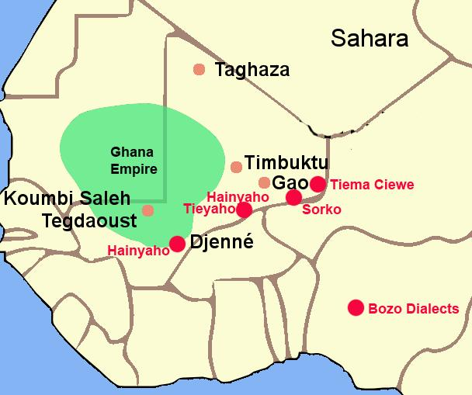

Fig. 2. The Ghana Empire 1000-1400 CE showing the ethnolinguistic groups along the Niger River. After <https://i.pinimg.com/564x/c6/a7/9b/c6a79b7443105f363ff965ebf420b7fd.jpg>

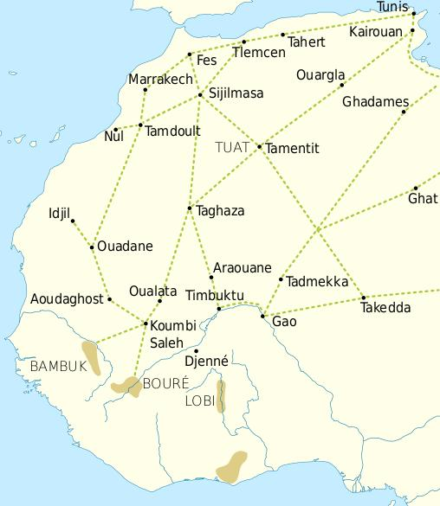

Fig. 3. Trade routes of the Western Sahara c. 1000-1500. Goldfields are indicated by light brown shading. After https://i.pinimg.com/564x/69/15/ce/6915ce6f4fd34025787fe59bd44f9eae.jpg

This trade resulted in an increasing surplus that helped expand urban centers such as Gao, Timbuktu and Djenné.

**Geographical Area:** Mali-Mande-Bandiagara Cliff

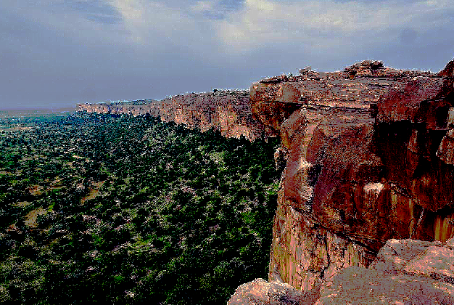

Fig. 4. Mali-Mande-Bandiagara Cliff after <https://img.ev.mu/images/attractions/2208/960x640/799108.jpg>

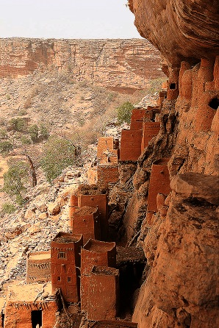

Fig. 5. View of a Bandiagara Cliffside village [14.231845°N 3.487967°W](https://tools.wmflabs.org/geohack/geohack.php?pagename=Bandiagara_Escarpment&params=14.231845_N_3.487967_W_type:landmark_dim:62km). After https://www.google.com/url?sa=i&rct=j&q=&esrc=s&source=images&cd=&ved=0ahUKEwj5waPJp5HZAhWBwVkKHZhgBSAQjRwIBw&url=https%3A%2F%2Fen.wikipedia.org%2Fwiki%2FBandiagara_Escarpment&psig=AOvVaw0Ir0wDNT368SI7kOytTx85&ust=1518007144365002

GPS: [14.231845°N 3.487967°W](https://tools.wmflabs.org/geohack/geohack.php?pagename=Bandiagara_Escarpment&params=14.231845_N_3.487967_W_type:landmark_dim:62km)

**Cultural Affiliation:** Dogon

**Medium:** wood

**Dimensions:**

**Weight:**

**Condition: original**

**Provenance:**

**Discussion:**

An ancient Dogon myth of the world before the appearance of death described elders as becoming too old. When they reached this age they would change themselves into a large water being, a Nommo, like a crocodile/ Then they would dwell in ponds and rivers and begin a new life, helping maintain the source of water for their descendants. Meanwhile, Nyerum, the female counterpart and Cosmic consort of Nommo would enforce the social responsibilities of the Dogon People for protecting the water sources that Nommo has created.

**References:**

Bouju, Jacky. 2003. The spirit of water: in the Dogon world, *Leonardo* (MIT Press)*,* 36(4): 279-280

Bouju, Jacky. 1991. Comments. In: Van Beek, Walter. “Dogon restudied: A field evaluation of the

work of Marcel Griaule,” *Current Anthropology* 32, 2: 139-168. S. 159-160.

Bouju, Jacky. 1984. *Graine de l'homme, enfant du mil*. Sociétés Africaines, 6. Paris:

Société d'Ethnographie.

Calame-Griaule, Geneviève. 1968. *Dictionnaire dogon. Dialecte Toro. Langue et*

*civilisation.* Langues et littératures de l’Afrique Noire, Bd. 4. Paris: Klincksieck.

Calame-Griaule, Geneviève/ 1987 [1965]. *Ethnologie et langage. La parole chez les Dogon.* Paris: Institut d’Ethnologie.

Calame-Griaule, Geneviève. 1991. “On the Dogon restudied,” *Current Anthropology* 32,5: 575-577.

Dieterlen, Germaine. 1941. *Les âmes des Dogons*. Paris: Institut d’Ethnologie.

Dieterlen, Germaine.1982. *Le titre d'honneur des Arou. Dogon, Mali*. Mémoires de la Société des

Africanistes. Paris: Société des Africanistes.

Dieterlen, Germaine. 1989. “Masks and mythology among the Dogon,” *African Arts* 22,3: 34-43.

Douglas, Mary. 1967. “If the Dogon…,” *Cahiers d’Études Africaines* 7,4: 659-672.

Douglas, Mary. 1968. “Dogon culture – profane and arcane,” *Africa* 38: 16-25.

Griaule, Marcel. 1938. *Masques dogons*. Paris: Institut d’Ethnologie.

Griaule, Marcel. 1948. Valeur symbolique du vêtement Dogon. *Revue d’esthétique* 1: 195.

Griaule, Marcel. 1975 [1948]. *Dieu d’eau. Entretiens avec Ogotemmêli*. Paris: Fayard.

Griaule, Marcel. 1980 [1970]. *Schwarze Genesis. Ein afrikanischer Schöpfungsbericht.* Frankfurt:

Suhrkamp (dt. Übers.von *Dieu d’eau. Entretiens avec Ogotemmêli* 1975).

Griaule, Marcel und Germaine Dieterlen 1965. *Le renard pâle*. Paris: Institût d’Ethnologie.

Jolly, Eric. 2003. *Le pouvoir en miettes. Récits d'intronisation d'un hogon. Pays dogon, Mali.*

Classiques Africains, 29. Paris: Classiques Africains.

Jolly, Eric. 1998-99. « Chefs sacrés, chefs de guerre, deux pôles du pouvoir, » *Clio en Afrique* 5.

Mayor Anne, Eric Huysecom, Alain Gallay *et al*. 2005. “Population dynamics and

paleoclimate over the past 3000 years in the Dogon Country, Mali,” *Journal of*

*Anthropological Archaeology* 24: 25-61.

N’Diaye, Francine. 1971. Iconologie des poulies de métier à tisser dogon. *Objets et Mondes*

11: 355-370.

N’Diaye, Francine. 1995. *L’art du pays dogon dans les collections du Musée de l’Homme*. Zürich: Museum Rietberg.

Van Beek, Walter. 1991. “Dogon restudied. A field evaluation of the work of Marcel Griaule*,”*

*Current Anthropology* 32, 2: 139-168.

Van Beek, Walter. 1992. On myth as science fiction*. Current Anthropology* 33,2: 214-216.

Van Beek, Walter. 2003a. La vie et l’au-delà. Organisation sociale des Dogon. In: Bedaux, Rogier M.A.

und J. Diderik van der Waals (Hg.). *Regards sur les Dogon du Mali.* Leiden: Rijksmuseum voor Volkenkunde, Gent: Éditions Snoeck. S. 93-94.

Van Beek, Walter. 2003b. La religion des Dogon. In: Bedaux, Rogier M.A. und J. Diderik van der Waals (Hg.). *Regards sur les Dogon du Mali.* Leiden: Rijksmuseum voor Volkenkunde, Gent: Éditions Snoeck. S. 95-103.

Van Beek, Walter. 2005. Haunting Griaule. Experiences from the restudy of the Dogon. *History in Africa*

31: 43-68.

Van Beek, Walter und Pietke Banga 1990. The Dogon and their trees. In: David Parkin und Elisabeth

Croll. *Cultural understandings of the environment.* London: School of Oriental and

African Studies.